Event Management System
TECHNICAL REPORT



SUBMITTED BY
[Student Name]
[AG #]
ADVISED BY
[Supervisor Name]

A TECHNICAL REPORT SUBMITTED IN PARTIAL FULFILLMENT OF REQUIREMENT FOR THE DEGREE OF
BACHELORS OF SCIENCE
IN
INFORMATION TECHNOLOGY
DEPARTMENT OF COMPUTER SCIENCE
FACULTY OF SCIENCES
UNIVERSITY OF AGRICULTURE FAISALABAD
DECLARATION

I hereby declare that the contents of the report Event Management System are project of my own research and no part has been copied from any published source (except the references). I further declare that this work has not been submitted for award of any other diploma/degree. The university may take action if the information provided is found false at any stage. In case of any default the scholar will be proceeded against as per UAF policy.

_________________

[ Student Name]
CERTIFICATE

To,
The Controller of Examinations,
University of Agriculture,
Faisalabad.

The supervisory committee certify that [Your Name] [AG #] has successfully completed his project in partial fulfillment of requirement for the degree of M.Sc. Computer Science under our guidance and supervision.

_____________________________________
[Supervisor Name]
Supervisor

_____________________________________
[Member Name]
Member

_______________________________________
Dr. Muhammad Ahsan Latif
Incharge,
Department of Computer Science

ACKNOWLEDGEMENT

I thank all who in one way or another contributed in the completion of this report. First, I thank to ALLAH ALMIGHTY, most magnificent and most merciful, for all his blessings. Then I am so grateful to the Department of Computer Science for making it possible for me to study here. My special and heartily thanks to my supervisor, [Supervisor Name] who encouraged and directed me. His/her challenges brought this work towards a completion. It is with his/her supervision that this work came into existence. For any faults I take full responsibility. I am also deeply thankful to my informants. I want to acknowledge and appreciate their help and transparency during my research. I am also so thankful to my fellow students whose challenges and productive critics have provided new ideas to the work. Furthermore, I also thank my family who encouraged me and prayed for me throughout the time of my research. May the Almighty God richly bless all of you

ABSTRACT

The University Event Management System (UEMS) is a comprehensive, real-time campus governance platform designed to modernize and digitize institutional event coordination. Addressing the inefficiencies of traditional, paper-based administrative processes, UEMS introduces a secure, multi-role ecosystem tailored specifically for students, teachers, and administrators. Built upon a decoupled three-tier architecture utilizing a modern JavaScript stack (MongoDB, Express.js, React, Node.js), the platform ensures high performance, scalability, and robust data management. Core functionalities include dynamic QR-code generation for secure gate check-ins, strict Role-Based Access Control (RBAC) for event proposal and approval pipelines, and automated attendance tracking with data export capabilities. Furthermore, the system integrates Socket.io to facilitate low-latency, bidirectional communication through live event chat lobbies and personalized, system-wide push notifications. A distinguishing feature of UEMS is the seamless integration of the Google Gemini Generative AI model, which acts as a context-aware platform advisor capable of analyzing live database aggregates to intelligently assist users within a secure, read-only sandbox. By replacing fragmented campus bulletin systems with a centralized, AI-enhanced web application, UEMS significantly improves collaborative engagement, operational security, and administrative oversight across the university environment.

Table of Contents

Chapter 1 - INTRODUCTION 5
1.1 Background: 5
1.2 Description: 5
1.3 Problem Statement: 5
1.4 Scope: 5
1.5 Objectives: 6
1.6 Feasibility: 6
1.7 Requirements: 7
1.7.1 Functional Requirements 7
1.7.2 Non- Functional Requirements 7
1.7.3 Hardware Requirements 8
1.7.4 Software Requirements 8
1.8 Stakeholders: 8
Chapter 2 – MATERIALS & METHODS 9
2.1 Process Model: 9
2.2 Tools & Technologies 9
2.3 Design: 9
2.3.1 Use Case Diagrams: 10
2.3.3 Sequence Diagram: 16
2.3.4 Class Diagram: 19
2.3.5 Data Flow Diagram: 20
2.3.6 ER Diagram: 24
2.3.7 Database Model: 24
2.3.8 Architecture: 25
Chapter 3 - RESULTS & DISCUSSION 27
3.1 Testing: 27
3.2 Test Cases: 27
3.3 Conclusion: 29
Chapter 4 - USER MANUAL 30
References 31

List of Figures

Figure ‎1.1 Stakeholders 8
Figure ‎2.1 Agile Activities 9
Figure 2.‎2 Use Case Diagram 12
Figure 2.3 Sequence Diagram 19
Figure 2.4 Class Diagram 20
Figure ‎2.5 Context Diagram 22
Figure ‎2.6 Level 0 DFD 22
Figure 2.7 Level 1 DFD 23
Figure ‎2.8 Entity Relationship Diagram 24
Figure 2.9 Database Model 25
Figure ‎2.10 Applications's Architecture 26
Figure ‎4.1 Signing in 30

List of Tables

Table 2. 1: Add User 15

Table 3. 1: User login Test Case 29

Chapter 1 - INTRODUCTION

1.1 Background:
Modern university campuses are dynamic environments characterized by a continuous stream of academic seminars, cultural festivals, departmental workshops, and administrative gatherings. The successful execution of these events is vital for fostering student engagement, institutional community, and academic enrichment. However, the traditional logistical frameworks employed to manage these activities are often highly fragmented and heavily reliant on manual processes. Universities frequently depend on physical bulletin boards, disparate email chains, third-party form builders (such as Google Forms), and paper-based ticketing systems. This decentralized approach creates a significant disconnect between event organizers (teachers and faculty), attendees (students), and regulatory overseers (administrators).
The reliance on antiquated methods introduces several critical operational pain points. For students, discovering relevant campus events is often left to chance, hindered by cluttered notice boards and scattered social media groups. For teachers and faculty, organizing an event involves navigating a cumbersome administrative pipeline—from securing approvals to manually compiling registration spreadsheets. Furthermore, on the day of the event, physical gate check-ins and manual ID verifications create severe bottlenecks, resulting in long queues and an increased likelihood of attendance fraud or unauthorized entry. Once an event concludes, gathering structured feedback and auditing attendance metrics becomes an exhaustive manual task, depriving administrators of the actionable data needed to evaluate campus engagement or allocate future funding effectively.
Communication gaps further exacerbate these inefficiencies. When event logistics change—such as a shift in venue or a time delay—broadcasting these updates instantly to registered attendees is nearly impossible within legacy systems, leading to confusion and decreased participation. There is a distinct absence of a unified, real-time collaborative space where students and organizers can interact prior to or during an event.
Recognizing these systemic limitations, the University Event Management System (UEMS) was conceptualized as a comprehensive digital transformation initiative. The project aims to replace these disparate, paper-heavy workflows with a centralized, secure, and highly interactive web-based ecosystem. By leveraging modern web technologies—such as robust relational document databases, instantaneous Socket.io web-sockets, and dynamic QR-code cryptography—UEMS seeks to automate the entire event lifecycle. Furthermore, the integration of advanced generative AI (Google Gemini) introduces a forward-looking approach to campus navigation, transforming the platform from a mere administrative tool into an intelligent, data-driven campus companion. Ultimately, UEMS is designed to restore efficiency, security, and collaborative synergy to university event governance.

1.2 Description:
The University Event Management System (UEMS) is a centralized, multi-tier web application designed to govern the entire lifecycle of campus events from initial proposal to post-event analysis. Built on a decoupled architectural framework utilizing the MERN stack (MongoDB, Express.js, React, Node.js), UEMS delivers a high-performance, real-time ecosystem that caters to the distinct operational needs of students, teaching faculty, and university administrators.
At its core, the platform operates on a strict Role-Based Access Control (RBAC) mechanism, dividing the system into three distinct, secure dashboards:
Beyond standard CRUD (Create, Read, Update, Delete) operations, UEMS introduces advanced technical integrations to ensure a dynamic user experience. The application utilizes Socket.io to power persistent, low-latency, bidirectional communications. This facilitates real-time user notification bells and active discussion lobbies specific to each event, ensuring all stakeholders remain informed of instant updates.
Furthermore, UEMS pioneers the use of contextual Artificial Intelligence within campus governance by integrating the Google Gemini AI API. This embedded generative AI engine acts as an intelligent platform advisor. By aggregating live, read-only database snapshots (such as active event lists and registration counts) into a secure, sandboxed context prompt, the Gemini assistant can dynamically answer complex user queries, offering personalized event recommendations and deep administrative insights without compromising sensitive user data.
In summary, UEMS is a robust, end-to-end digital solution that harmonizes database management, secure cryptographic authentication, real-time web-socket communication, and advanced AI to create a unified, paperless, and highly interactive campus event environment.

1.3 Problem Statement:
Despite the rapid digitization of higher education, the logistical coordination of on-campus events remains largely reliant on outdated, manual, and disconnected systems. Currently, university stakeholders—including students, faculty organizers, and administrative staff—face significant operational bottlenecks when planning, executing, and attending institutional activities. The reliance on physical bulletin boards, scattered email threads, and disparate third-party registration forms creates a fragmented discovery process, often leading to low student engagement and a lack of awareness regarding campus life.
For faculty and event organizers, the administrative workflow is highly inefficient. Securing event approvals requires navigating a cumbersome chain of manual requests, while on-the-day logistics are plagued by paper-based ticketing and manual student ID verifications. This not only results in severe bottlenecks and long queues at venue gates but also increases the risk of unauthorized entry and inaccurate attendance tracking. Furthermore, the absence of a unified, real-time communication channel prevents organizers from instantly broadcasting critical updates—such as sudden venue changes or delays—leaving attendees misinformed and disconnected.
At the macro level, administrators lack a centralized dashboard to oversee campus activities. Post-event data collection is largely non-existent or highly manual, depriving the university of actionable insights and analytics required to measure departmental engagement, optimize budget allocations, and improve future event planning. Consequently, there is an urgent institutional need for a cohesive, secure, and intelligent digital ecosystem that can automate administrative workflows, ensure seamless and verifiable access control, and facilitate instantaneous communication among all campus participants.

1.4 Scope:
The scope of the University Event Management System (UEMS) encompasses the design, development, and implementation of a secure, multi-role, 3-tier web ecosystem intended to digitize and streamline campus event coordination. The system is designed to entirely replace traditional manual processes, such as physical bulletin boards and paper ticketing, with a centralized, real-time digital platform.
The expected work effort, functional boundaries, and deliverables of this project include:
Role-Based Access Control (RBAC): Implementation of three distinct user dashboards with secure, token-based authentication for Students, Teachers (Hosts), and Administrators.
Student Operations: Capabilities for end-users to browse a dynamic event catalog, register for active events, generate secure digital gate passes utilizing dynamic QR codes, participate in real-time event chat lobbies, and submit post-event ratings and reviews.
Teacher (Host) Operations: Tools for event creation and proposal submission, live attendee table management, real-time QR code scanning for venue check-ins, attendance record exportation (via CSV), and lobby discussion leadership.
Administrative Governance: Interfaces for platform operators to review, approve, or reject pending event proposals, manage the global user directory, broadcast real-time system alerts, and audit platform-wide engagement metrics.
Real-Time Communications Engine: Integration of WebSocket technology (Socket.io) to facilitate low-latency, bidirectional event chat lobbies and instant system-wide notifications without requiring page refreshes.
Intelligent Platform Assistant: Integration of a securely sandboxed Google Gemini AI chatbot to provide users with conversational, context-aware assistance based on live database aggregates and platform data.
Secure Asset Management: Cloud-based handling and dynamic rendering of media assets (user avatars and event cover banners) utilizing Cloudinary and Multer.
The project scope focuses strictly on the software development lifecycle, architectural design, and deployment of this web application, establishing a complete, decoupled client-server solution for the university environment.

1.5 Objectives:
The primary motivation behind the University Event Management System (UEMS) is to modernize and secure the way campus events are proposed, managed, and attended. Currently, university event coordination relies heavily on fragmented, manual processes such as paper ticketing and physical bulletin boards, which are inefficient and difficult to track. By implementing a centralized, real-time web platform, this project aims to bridge the communication gap between students, hosting teachers, and administrators while providing deep insights into campus engagement. The following outlines the overarching goal of the UEMS project, followed by the specific, actionable objectives required to achieve it.
- Goal (more broad): We want to digitize and streamline the university's event coordination process by developing a secure, centralized, and real-time multi-role web ecosystem.
- Objective (more specific): Develop a decoupled 3-tier client-server architecture utilizing MongoDB, Express.js, React, and Node.js.
- Objective (more specific): Implement Role-Based Access Control providing distinct, secure dashboards for Students, Teachers, and Administrators.
- Objective (more specific): Integrate Socket.io to facilitate real-time, low-latency event chat lobbies and instant system notifications.
- Objective (more specific): Create a dynamic event catalog that enables digital registration and generates dynamic QR codes for gate passes.
- Objective (more specific): Incorporate the Google Gemini AI API to act as a conversational platform assistant contextualized with live database data.
- Objective (more specific): Build host and admin tools for event proposal workflows, live QR scanning at the gate, and attendance CSV exportation.

1.6 Feasibility:
Before fully committing resources to the development of the University Event Management System (UEMS), it is crucial to evaluate the project's viability across multiple domains. A feasibility study ensures that the proposed transition from a fragmented, manual event coordination process to a fully digitized, real-time web ecosystem is both practical and highly beneficial for the university. By analyzing our technological infrastructure, financial constraints, and the campus's readiness for digital adoption, we can confidently determine the likelihood of the project's success. The following subsections break down the specific feasibility areas for the UEMS project.
1.6.1 Technical Feasibility – The UEMS project is highly feasible from a technical standpoint. The system relies on the MERN stack (MongoDB, Express.js, React, Node.js), which is a proven, well-documented, and robust framework for building decoupled 3-tier architectures. The integration of specialized technologies, such as Socket.io for real-time WebSockets and the Google Gemini API for the AI assistant, are fully supported by extensive developer resources. The chosen stack easily handles the required data routing, user authentication, and dynamic QR code generation.
1.6.2 Schedule Feasibility – This project is feasible within standard academic and developmental timeframes. By utilizing Agile methodologies, the decoupled nature of the React frontend and Node.js backend allows for parallel development. Core features like database schemas and Role-Based Access Control (RBAC) can be established in early sprints, leaving ample time in the schedule for testing complex integrations like the real-time event lobbies and QR scanning pipelines.
1.6.3 Economic Feasibility – The economic feasibility of the UEMS is excellent. The foundational technologies—including React, Node.js, and Tailwind CSS—are entirely open-source and free to use. Furthermore, cloud services required for the project, such as MongoDB Atlas for database hosting, Cloudinary for media asset storage, and the Gemini API, offer generous free tiers that are more than sufficient for the development, testing, and initial deployment phases. This makes the project highly cost-effective compared to purchasing commercial enterprise software.
1.6.4 Cultural Feasibility – The cultural feasibility is extremely high. The university demographic, consisting primarily of students and academic faculty, is highly technologically literate and accustomed to mobile-first digital environments. Replacing physical bulletin boards and paper tickets with a centralized web platform and digital QR gate passes aligns perfectly with modern expectations for convenience. Additionally, this paperless approach supports the university's environmental sustainability goals.
1.6.5 Legal/Ethical Feasibility – The system is designed with strict adherence to data privacy, making it legally and ethically feasible. User security is prioritized by cryptographically hashing passwords via bcrypt and managing sessions through secure, HTTP-only JWT cookies to prevent unauthorized data access. Furthermore, the integration of the generative AI engine is securely sandboxed; system prompts explicitly prevent the AI from accessing or leaking sensitive user information, ensuring ethical data handling.
1.6.6 Resource Feasibility – Sufficient resources are available to complete this project. Development requires only standard computing hardware, stable internet access, and open-source integrated development environments (IDEs) such as Visual Studio Code. Because the application is web-based and utilizes cloud-hosted databases, the university does not need to invest in on-premise physical servers or specialized hardware for the deployment phase.
1.6.7 Operational Feasibility – Operationally, the UEMS directly addresses and solves existing administrative pain points, ensuring a high rate of user adoption. The system automates tedious manual tasks for teachers, such as compiling attendance via CSV exports and verifying registrations at the door. For administrators, it provides an instant, clear overview of campus engagement. Because it drastically improves efficiency for all three user roles (Students, Teachers, and Admins), the operational feasibility is exceptionally strong.

Requirements:

1.7.1 Functional Requirements
Any requirement which precisely specifies what the system should do is called functional requirement of the system. In other words, a functional requirement will describe a particular behavior of function of the system when certain conditions are met.
FR01: User Authentication & Session Management
FR01-01 | System shall allow users to register an account by providing a username, email, full name, password, and profile avatar image.
FR01-02 | System shall cryptographically hash all user passwords using the Bcrypt hashing algorithm before storing them in the database.
FR01-03 | System shall authenticate matching credentials and issue secure HTTP-only Access and Refresh JSON Web Tokens (JWT) upon login.
FR01-04 | System shall clear all secure client cookies and remove corresponding refresh tokens from the database upon user logout.
FR02: Student Operations & Discovery Hub
FR02-01 | System shall provide a centralized digital event catalog featuring dynamic live searching, category filtering, and departmental sorting.
FR02-02 | System shall allow authenticated students to register for active, approved campus events.
FR02-03 | System shall automatically generate a secure digital gate pass featuring a dynamic QR code upon successful event registration.
FR02-04 | System shall allow students to submit a post-event rating from 1 to 5 stars and a text comment after the event date and time have passed.
FR02-05 | System shall enforce a compound unique index constraint on the reviews collection to completely prevent multiple reviews from the same student for a single event.

FR03: Teacher (Host) Event Operations
FR03-01 | System shall allow authenticated teachers to submit event proposals containing a title, description, logistics parameters, and a cover banner.
FR03-02 | System shall route newly submitted teacher event proposals into a pending state and alert platform administrators for review.
FR03-03 | System shall render a real-time registered attendee data table accessible exclusively to the designated hosting teacher.
FR03-04 | System shall allow event hosts to export the complete attendee and verification table into a structured, downloadable CSV file
FR04: Gate Verification & QR Scanning Pipeline
FR04-01 | System shall provide an integrated camera-based scanning interface on the host dashboard to scan digital student gate passes at the venue entrance.
FR04-02 | System shall parse the scanned QR code payload to securely extract the associated student ID and target event ID.
FR04-03 | System shall verify whether the student holds an active registration record for the event and confirm that they have not already checked in.
FR04-04 | System shall dynamically move the verified student ID into the checkedIn database array and instantly broadcast a success status message to the host.
FR05: Real-Time WebSocket Communication Lobbies
FR05-01 | System shall establish a bidirectional Socket.io WebSocket connection to place users into distinct, event-specific chat lobby rooms.
FR05-02 | System shall instantly broadcast text messages to all active participants inside a specific event lobby room without requiring an explicit page refresh.
FR05-03 | System shall execute database writes to save persistent chat log documents to the lobby messages collection.
FR05-04 | System shall automatically assign users to private notification rooms upon login to deliver real-time system alerts and approval changes directly to their dashboard.
FR06: Contextual Gemini AI Assistant
FR06-01 | System shall run aggregation pipelines to compile a live snapshot of active events, category distributions, and registration tallies upon an AI request.
FR06-02 | System shall inject this live database aggregate data directly into the system-context prompt string routed to the Google Gemini AI engine.
FR06-03 | System shall deliver a context-aware, conversational response to complex campus inquiries based on the real-time data snapshot.
FR06-04 | System shall enforce strict sandboxing instructions within the system prompt to block the retrieval or exposure of fields like emails, tokens, and hashed passwords.
FR07: Administrative Platform Governance
FR07-01 | System shall present a centralized approval console displaying all pending teacher event proposals to platform operators.
FR07-02 | System shall allow administrators to approve or reject pending event proposals, immediately publishing approved events to the global catalog.
FR07-03 | System shall automatically dispatch a real-time dashboard notification and alert indicating the final approval or rejection status to the organizing teacher.
FR07-04 | System shall compile and render an administrative analytics dashboard displaying key platform-wide metrics, including monthly attendance growth and category breakdowns.

1.7.2 Non- Functional Requirements
Any requirement which specifies how the system performs a certain function is called non-functional requirement. In other words, a non-functional requirement will describe how a system should behave and what limits there are on its functionality. Non-functional requirements generally specify the system’s quality attributes or characteristics.

NFR01: System shall remain available 24/7 to its users.
NFR02: System shall explicitly isolate and secure access for three distinct types of users i.e., admin, teacher, and student.
NFR03: System shall provide helper tooltips and descriptive error flags across option buttons and navigation links to assist non-technical users.
NFR04: System shall broadcast chat messages sent within an event lobby room to all active WebSocket clients in less than 500 milliseconds.
NFR05: System shall parse and validate a scanned dynamic QR code payload at the gate in less than 1 second to maximize venue entry throughput.
NFR06: System shall utilize fully asynchronous, non-blocking middleware chains to concurrently support at least 500 active WebSocket lobby connections during major campus events.
NFR07: System shall safeguard all authenticated sessions via secure HTTP-only JSON Web Tokens (JWT) to fully prevent cross-site scripting token theft.
NFR08: System shall enforce strict sandboxing rules within the generative AI system prompt to completely block the retrieval or processing of sensitive data fields like user emails and hashed passwords.
NFR09: System shall be structured as a strictly decoupled client-server architecture, allowing the React presentation tier and the Node.js application tier to be updated independently.
NFR10: System user interfaces built with React and Tailwind CSS shall be fully responsive across mobile, tablet, and desktop viewports, prioritizing the mobile experience for gate check-ins.

1.7.3 Hardware Requirements
To ensure the University Event Management System (UEMS) operates efficiently on the end-user's side, the following minimum and recommended hardware specifications are defined:
Processor: Intel Core i3 CPU (2.0 GHz) or equivalent AMD processor.
Hard Disk: 500 MB of free storage space (for local browser caching and session storage data).
RAM: 2 GB or more
Network Interface: Standard Wi-Fi or cellular data card (required for real-time WebSocket communication and QR code validation pipelines).
Camera: Integrated front/rear device camera (strictly required for event hosts/teachers executing gate check-in QR scanning functionality).

1.7.4 Software Requirements
The University Event Management System (UEMS) is a fully cross-platform web application accessible via any modern browser environment. The minimum software requirements on the user's side include:
Operating System: Windows 7 or higher, macOS X or higher, Linux, Android (version 8.0 or higher), or iOS (version 13.0 or higher).
Web Browser: Google Chrome (version 90 or higher), Mozilla Firefox (version 88 or higher), Microsoft Edge, or Apple Safari.
JavaScript Compatibility: JavaScript must be explicitly enabled in the browser settings to support React SPA routing, Socket.io duplex connections, and live UI updates.
Cookies: Browser must accept cookies to facilitate secure HTTP-only JSON Web Token (JWT) session management.

Stakeholders:
Stakeholders are different people who would be interested in the software, or stakeholders are all those with an interest or role in the project or who are impacted by the project. We need to understand that it is the actual user who will eventually use the system and hence accept or reject the product. Therefore, ignoring the needs of any user class may result in the system failure. For the University Event Management System (UEMS), the primary stakeholders are categorized based on their level of interest and influence over the platform:
Students: These are the primary end-users of the platform. They have a high interest in discovering active campus events, registering smoothly, and using digital gate passes via dynamic QR codes. Their needs directly dictate the usability and mobile-responsiveness of the presentation tier.
Teachers (Hosts): These stakeholders act as event organizers. They have a high operational interest in the system, relying on it to submit event proposals, manage registered attendee tables, scan student QR codes at the gate, and export attendance data as CSV files for academic record-keeping.
Administrators: These are the platform operators who hold the highest level of influence. They monitor platform-wide metrics, manage global user directories, broadcast real-time system alerts, and oversee the governance pipeline by reviewing, approving, or rejecting pending teacher event proposals.
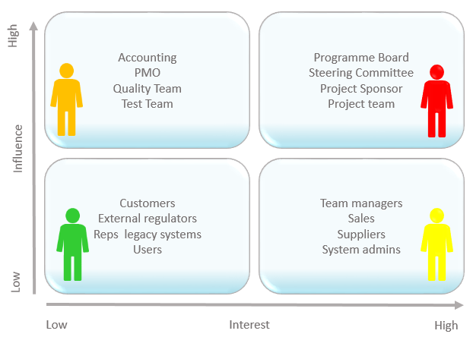
Figure 1.1 Stakeholders

Chapter 2 – MATERIALS & METHODS

2.1 Process Model:
A software process model is an abstraction of the software development lifecycle that provides a structured framework for planning, executing, and managing a project. The selection of an appropriate process model is highly significant because it dictates the timeline, testing phases, and overall methodology for transforming abstract requirements into a functional system. For a multi-role web ecosystem like the University Event Management System (UEMS), a flexible and highly adaptable approach is necessary to successfully integrate distinct, complex technologies such as real-time WebSockets, dynamic QR code generation, and generative AI.
For the development of UEMS, the Agile process model has been selected. Agile is an iterative and incremental approach that focuses on rapid application development, flexibility, and continuous delivery. Rather than attempting to build the entire system in one massive linear sequence, the Agile model divides the project into smaller, manageable cycles or sprints. During these sprints, individual components and functionalities are developed, tested, and assembled into a working prototype.
The Agile methodology is the ideal fit for the UEMS project due to its decoupled 3-tier architecture. Using this model, the development team can build and test the Node.js and MongoDB backend independently while simultaneously prototyping the React frontend. As individual features are completed—such as the role-based authentication pipeline or the Socket.io event lobbies—they can be immediately integrated and evaluated. This continuous delivery cycle allows the development team to quickly adapt to technical challenges, refine the Google Gemini AI prompts, and ensure the final user dashboards perfectly meet the practical needs of the university.

Figure 2.1 Agile Activities

2.2 Tools & Technologies
The University Event Management System (UEMS) is developed using an advanced stack of modern, high-performance frameworks and open-source utilities. Below is a brief description of each tool and technology utilized during the project development:
MongoDB: A NoSQL document-oriented database used as the data tier to store system records like users, events, reviews, and logs using flexible, indexed JSON-like documents.
Express.js: A minimal and flexible Node.js web application framework used to build the server-side application tier, handling RESTful API routing and middleware pipelines.
React: A component-based JavaScript presentation library used to construct a fast, single-page application (SPA) front-end featuring dynamic dashboards for all user roles.
Node.js: An open-source, cross-platform JavaScript runtime environment built on Chrome's V8 engine, executing the asynchronous, non-blocking backend application logic.
Socket.io: A JavaScript library enabling bidirectional, low-latency, real-time communication between the client and server to power instant messaging and system notifications.
Google Gemini API: A state-of-the-art generative artificial intelligence engine used via the official SDK to serve as a context-aware chatbot assistant utilizing live platform data.
Tailwind CSS v4: A utility-first CSS framework integrated with Vite to style the presentation tier, delivering clean layouts, modern custom animations, and responsive components.
Cloudinary: A cloud-based media asset management service used alongside Multer to securely upload, store, and dynamically optimize user avatars and event cover banners.
Bcrypt: A cryptographic password-hashing function used on the backend to securely salt and hash credentials before storing them inside the database collection.
JSON Web Tokens (JWT): An open industry standard used to safely transmit claims between parties, enabling secure session validation via access and refresh cookie pairs.
Mongoose: An asynchronous Object Data Modeling (ODM) library for MongoDB and Node.js that manages database relationships, dynamic arrays, and strict schema validation.
Postman: A collaborative API development platform used during engineering sprints to build, test, and debug HTTP endpoints and session cookies across backend routers.
Visual Studio Code: A lightweight but powerful source-code editor used as the primary integrated development environment (IDE) for writing, debugging, and refactoring code.

2.3 Design:
The design phase of the University Event Management System (UEMS) serves as the architectural blueprint for translating system requirements into a structured, reliable, and high-performance software solution. Designing a multi-role, real-time web ecosystem requires a comprehensive layout of both the static structures and dynamic interactions that govern the platform. By establishing rigorous design specifications, the development team ensures complete data integrity, robust role-based access boundaries, and seamless communication between decoupled computing tiers.
To provide a complete technical overview, the system design is modeled through a series of Unified Modeling Language (UML) diagrams, structural data schemas, and architectural layouts. The structural design is defined through Class and Database Models that map out backend controllers, data types, and collection schemas. The behavioral design is illustrated using Use Case Diagrams, textual Usage Scenarios, and Sequence Diagrams to map exactly how students, teachers, and administrators interact with real-time pipelines. Finally, the systemic flow and deployment topology are captured through detailed Data Flow Diagrams and a 3-Tier System Architecture layout. Together, these specifications establish a reliable roadmap for implementation and testing.

2.3.1 Use Case Diagrams:
A use case is a functionality the users need from the system. A use case diagram depicts the relationships among the actors and use cases. Generally, a single use case is supposed to cover all the actions or events that an actor can perform on the system at one go. The size of use case should not be very large or very small. For example, Add User, Manage Profile, View Sales Report, Update Order etc. are good medium size use cases. Whereas Enter Password, Display Error Message etc. are very small use cases and Manage Sale & Purchase is a very large use case.
The components in a use case diagram include:
Actors:
Actors are first thing you need to find for the use case diagram. Actors represent external entities of the system. These can be people or things, such as external hardware that interact with the system. For example, if an online store is being modeled there can be more than one actor that interacts with the store functionality. Such as the Customer and stocker will be the actors in the system. It is represented simply by a stick figure with its name at the bottom of it.

Actor
Use Cases:
Use cases are functional parts of the system. They figure out what actions/functionalities a user will perform. Use cases are basically the functional requirements that you have pointed out in the functional and non-functional requirements topic. For example: The customer "browses the catalog", "chooses items to buy", and "pays for the items". Here browse catalog, buy item and pay for item are the use cases. Many actors can share a single use cases. The notation for a use case is an ellipse. As it is displayed below:
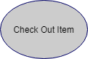
Associations:

Associations between actors and use cases are indicated in use case diagrams by solid lines. An association exists whenever there is direct interaction between actor and use case. Associations are modeled as lines connecting use cases and actors to one another, with an arrowhead on one end of the line.
System boundary:

System’s boundary is drawn by a rectangle that contains use cases. The actors are placed outside the system boundary and use cases inside it.
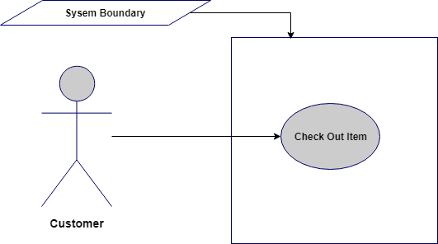
Relationship between Use cases:
- Include/Uses:
Include relationship is a relationship in which one use case (the base use case) includes the functionality of another use case (the inclusion use case). <<include>> use cases must be used by the use cases that use them before the latter can be complete. It is displayed in the diagram editor as a dashed line with an open arrow pointing from the base use case to the inclusion use case. The keyword «include» is attached to the connector.
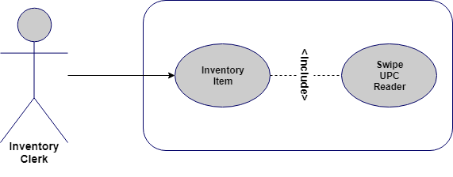
- Extend:
A use case extends another use case to do more than the latter. It extends the functionality of one use case to further level. is displayed in the diagram editor as a dashed line with an open arrowhead pointing from the extension use case to the base use case. The arrow is labeled with the keyword «extend».
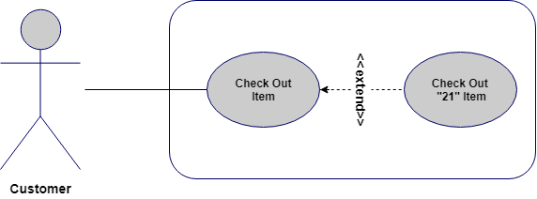
Use Case Diagram:

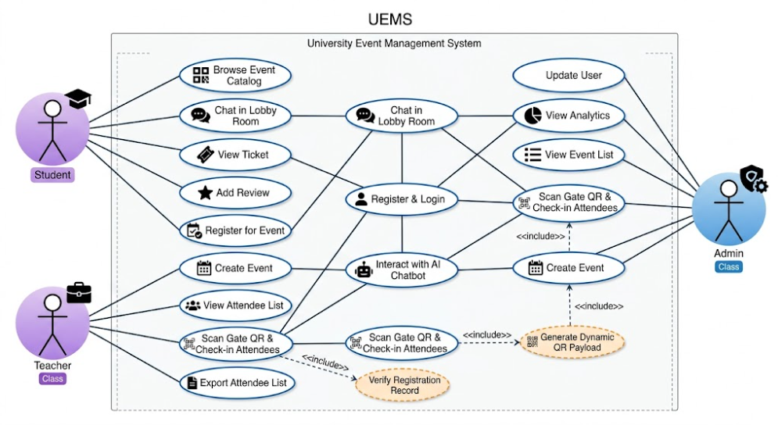
Figure 2.2 Use Case Diagram

2.3.2 Usage Scenario
Usage scenario is the actual text-based representation of the use case, among various representation methods discussed above. A usage scenario is likely to have various sections depending upon the level of details required in a given system. There is no fixed standard so far for number of sections in a use case (usage scenario).
Following is a typical table structure for usage scenario, note that it is not mandatory to write a usage scenario in the table format only, and it is likely that you will find different structures for the same representation.

Use Case Title | User Registration
Abbreviated Title | UC-01
Use Case Id | FR-01
Description: A new user (Student, Teacher) registers on the platform.
Pre Conditions: User has a valid email address.
Pre Conditions:
1. User navigates to registration page. |  | Exceptions
2. User enters details (name, email, password, avatar).
3. User submits form.
4. System hashes password and creates account.
5. System generates JWT token.
Post Conditions: Account created, user is authenticated.
Authority:
Authority: Guest

Let’s explore each section from the template provided above. (you have to make only usage scenario tables, below is description of its each part)

- Use Case Title
It is the name or label of the use case for which we are writing the usage scenario. Generally it must start with a Verb and it should consist of 2 to 4 words e.g. Add User, Manage User Roles etc.

Use Case Title | Add User

- Use Case Id
Sometimes use cases are indexed for better reference in overall project documentation/artifacts. This can be any form of series e.g. 1, 2, 3 etc. Priority based use case id is another famous use for this section. Use cases are indexed to present their importance in the system. You would want to set ascending or descending rating or priority for all use cases i.e. the most important use cases are ranked higher so that the project team knows what should be implemented first in the upcoming phases/deliverable of the project.
- Requirement Id
The purpose of this section is same as ‘Use Case Id’ section. The number written against this section represents the corresponding functional requirements this use case belongs to. It is compulsory to index all the functional requirements properly before this section can be used:

Requirement Id | 3

- Description
It should be a very brief description of the use case under discussion. Generally this portion should consist of 2/3 lines.

Description | This use case is about adding a new user to existing system with the privileges defined at time of user account creation.
- Pre-Conditions
This section should enlist what must be true before this use case can be performed.

Pre Conditions:
  - All must-required information about the new user should be available.
  - Database should be available in online mode.

- Task Sequence & Exceptions
This is the most important section of the usage scenario. It is also referred as Success Scenario, Actions, (or simply) Scenario. This should be a list of actor’s interaction with the use case.

Task Sequence | Exceptions
- Administrator opts to Add a new user account.
- System asks for necessary information
- Administrator provides all the required information and opts to complete the operation.
- System after confirmation adds the new account.
- System sends the account creation email to the administrator’s email id and user’s email address.
- A log is saved on the successful operation of the use case.

Alternate scenarios could be more than one; in this case, it will be better to make a bold heading to show each alternate scenario separately. Again, there can be multiple ways to show the alternate scenarios.
Exceptions are any unhandled scenarios that must be discussed under this section. Sometimes there are ambiguous situations in start of project that might hurdle the flow of events in the Task Sequence portion. In such situations the details are provided in the Exceptions section. Generally, this section should be left blank as in case of final project, you will get fixed requirements at the start and thus there should be no ambiguity.

- Post Conditions
The conditions that must be true depending upon the successful use case are mentioned in this section.

Post Conditions:
    - A new user account is successfully created.

- Unresolved Issues
In addition to the Exceptions portion, we write unresolved issues (if any) in this section, so that in later phases (when the situation gets more clear).
Just like Exceptions section, this will be generally left blank (or its row can be deleted from the use case table-structure.
- Authority
The role that is allowed to perform this use case, in our current example it will be Administrator.
- Modification History
If a use case is updated in later stages of the project development, the versioning information should be mentioned in this section (version can be a series such as 1.0, 2.0, 3.0 or 1.1, 1.2, 1.3 etc.)
- Author
It means the author of this usage scenario. Put your project/group id in this section.
- Description
Any more details about author, revision of the use case should be provided in this section.
So final usage scenario is as follows:

Table 2. 1: Add User
Use Case Title | User Login
Use Case Id | UC-02
Requirement Id | FR-01
Description: User logs into their dashboard.
Pre Conditions: User has registered an account.
Task Sequence |  | Exceptions
1. User navigates to login.
2. User enters credentials and clicks Sign In.
3. System validates credentials.
4. System issues access and refresh tokens.
Post Conditions: User is authenticated and redirected to dashboard.
Unresolved issues:
Authority: Registered User
Modification history: 1.0
Author: <Project or Group ID>
Description:
Use Case Title | User Logout
Use Case Id | UC-03
Requirement Id | FR-01
Description: User logs out of the platform securely.
Pre Conditions: User is logged in.
Task Sequence |  | Exceptions
1. User clicks Logout.
2. System clears HTTP-only cookies.
3. System removes refresh token from database.
4. User is redirected to login page.
Post Conditions: User session is terminated.
Unresolved issues:
Authority: Registered User
Modification history: 1.0
Author: <Project or Group ID>
Description:
Use Case Title | Browse Events
Use Case Id | UC-04
Requirement Id | FR-02
Description: Student browses the catalog of approved events.
Pre Conditions: User is logged in as Student.
Task Sequence |  | Exceptions
1. Student navigates to Discovery page.
2. System retrieves active events.
3. Student applies category/department filters.
4. Student views event details.
Post Conditions: Student finds an event of interest.
Unresolved issues:
Authority: Student
Modification history: 1.0
Author: <Project or Group ID>
Description:
Use Case Title | Register for Event
Use Case Id | UC-05
Requirement Id | FR-02
Description: Student registers for an upcoming event.
Pre Conditions: Student is logged in, event has available capacity.
Task Sequence |  | Exceptions
1. Student clicks Register on event details.
2. System verifies eligibility and capacity.
3. System records registration.
4. System generates QR gate pass for Student.
Post Conditions: Student is registered and possesses a QR pass.
Unresolved issues:
Authority: Student
Modification history: 1.0
Author: <Project or Group ID>
Description:
Use Case Title | Submit Event Review
Use Case Id | UC-06
Requirement Id | FR-02
Description: Student submits a rating and review for a past event.
Pre Conditions: Student attended the event, event has concluded.
Task Sequence |  | Exceptions
1. Student navigates to past event details.
2. Student enters 1-5 star rating and comment.
3. Student submits review.
4. System validates unique review constraint.
5. System saves review.
Post Conditions: Review is published to the event page.
Unresolved issues:
Authority: Student
Modification history: 1.0
Author: <Project or Group ID>
Description:
Use Case Title | Submit Event Proposal
Use Case Id | UC-07
Requirement Id | FR-03
Description: Teacher submits an event proposal for admin approval.
Pre Conditions: User is logged in as Teacher.
Task Sequence |  | Exceptions
1. Teacher navigates to Create Event.
2. Teacher enters details (title, logistics, banner).
3. Teacher submits form.
4. System routes event to pending state.
5. System alerts Admin.
Post Conditions: Event is pending approval.
Unresolved issues:
Authority: Teacher
Modification history: 1.0
Author: <Project or Group ID>
Description:
Use Case Title | Export Attendee List
Use Case Id | UC-08
Requirement Id | FR-03
Description: Teacher exports a CSV of registered students.
Pre Conditions: User is Teacher, event has registrations.
Task Sequence |  | Exceptions
1. Teacher navigates to event dashboard.
2. Teacher views real-time registered attendee table.
3. Teacher clicks Export to CSV.
4. System compiles data and initiates CSV download.
Post Conditions: Teacher possesses attendee CSV file.
Unresolved issues:
Authority: Teacher
Modification history: 1.0
Author: <Project or Group ID>
Description:
Use Case Title | Scan QR Code Check-in
Use Case Id | UC-09
Requirement Id | FR-04
Description: Event host scans student QR passes at the gate.
Pre Conditions: Teacher is at the venue dashboard, Student has QR pass.
Task Sequence |  | Exceptions
1. Teacher opens scanner interface.
2. Teacher scans student QR code.
3. System parses payload for student ID.
4. System verifies active registration and no prior check-in.
5. System moves student to checkedIn list.
Post Conditions: Student is checked into the event.
Unresolved issues:
Authority: Teacher
Modification history: 1.0
Author: <Project or Group ID>
Description:
Use Case Title | Participate in Chat Lobby
Use Case Id | UC-10
Requirement Id | FR-05
Description: Registered users chat in the event's live lobby.
Pre Conditions: User is registered for the event.
Task Sequence |  | Exceptions
1. User navigates to event lobby.
2. System connects via Socket.io to event room.
3. User types message.
4. System broadcasts to all active participants.
5. System persists message to database.
Post Conditions: Message is delivered to lobby participants.
Unresolved issues:
Authority: Registered User
Modification history: 1.0
Author: <Project or Group ID>
Description:
Use Case Title | Query AI Chatbot
Use Case Id | UC-11
Requirement Id | FR-06
Description: User asks the Gemini AI chatbot a question about platform events.
Pre Conditions: User is logged in.
Task Sequence |  | Exceptions
1. User opens AI chat window.
2. User types inquiry.
3. System compiles live database aggregate.
4. System injects aggregate into Gemini prompt.
5. Gemini formulates context-aware response.
6. Response is displayed to user.
Post Conditions: User receives intelligent answer.
Unresolved issues:
Authority: Any User
Modification history: 1.0
Author: <Project or Group ID>
Description:
Use Case Title | Approve / Reject Event
Use Case Id | UC-12
Requirement Id | FR-07
Description: Admin reviews pending teacher event proposals.
Pre Conditions: User is Admin, pending events exist.
Task Sequence |  | Exceptions
1. Admin navigates to approval console.
2. Admin selects pending event.
3. Admin clicks Approve or Reject.
4. System updates event status.
5. System dispatches real-time notification to Teacher.
Post Conditions: Event is published or rejected.
Unresolved issues:
Authority: Admin
Modification history: 1.0
Author: <Project or Group ID>
Description:
Use Case Title | View Admin Analytics
Use Case Id | UC-13
Requirement Id | FR-07
Description: Admin views platform-wide metrics.
Pre Conditions: User is Admin.
Task Sequence |  | Exceptions
1. Admin navigates to main dashboard.
2. System aggregates attendance, categories, and registrations.
3. System renders charts and metrics.
Post Conditions: Admin views live analytics.
Unresolved issues:
Authority: Admin
Modification history: 1.0
Author: <Project or Group ID>
Description:

2.3.3 Sequence Diagram:
A sequence diagram simply depicts interaction between objects in a sequential order i.e. the order in which these interactions take place. We can also use the terms event diagrams or event scenarios to refer to a sequence diagram. Sequence diagrams describe how and in what order the objects in a system function. These diagrams are widely used by businessmen and software developers to document and understand requirements for new and existing systems.
Sequence Diagram Notations:
Actors – An actor in a UML diagram represents a type of role where it interacts with the system and its objects. It is important to note here that an actor is always outside the scope of the system we aim to model using the UML diagram.
Class Roles or Participants:
Class roles describe the way an object will behave in context. Use the UML object symbol to illustrate class roles, but don't list object attributes.
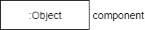
Activation or Execution Occurrence:
Activation boxes represent the time an object needs to complete a task. When an object is busy executing a process or waiting for a reply message, use a thin gray rectangle placed vertically on its lifeline.
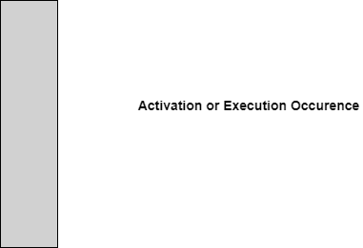
Messages
Messages are arrows that represent communication between objects. Use half-arrowed lines to represent asynchronous messages. Asynchronous messages are sent from an object that will not wait for a response from the receiver before continuing its tasks. For message types, see below.
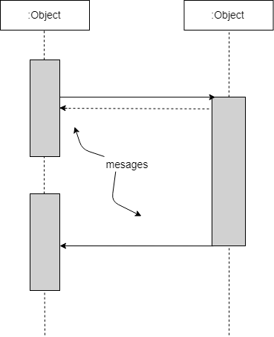
Lifelines
Lifelines are vertical dashed lines that indicate the object's presence over time.
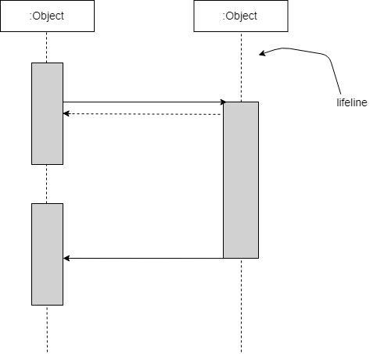
Destroying Objects
Objects can be terminated early using an arrow labeled "<< destroy >>" that points to an X. This object is removed from memory. When that object's lifeline ends, you can place an X at the end of its lifeline to denote a destruction occurrence.
Loops
A repetition or loop within a sequence diagram is depicted as a rectangle. Place the condition for exiting the loop at the bottom left corner in square brackets [ ].
Sequence Diagram Example (for item return use case):
Note: Make sequence diagram for each use case illustrated in use case diagram

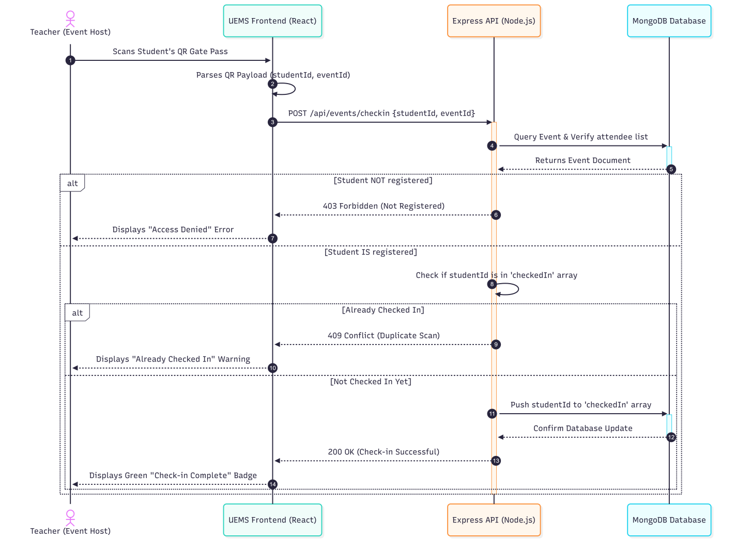
Figure 2.3 Sequence Diagram

2.3.4 Class Diagram:
A class diagram is a type of static structure diagram that describes the structure of a system by showing the system's classes, their attributes, operations (or methods), and the relationships among objects. For further reading visit: https://creately.com/blog/diagrams/class-diagram-relationships/. Below is the class diagram for library management system discussed above.
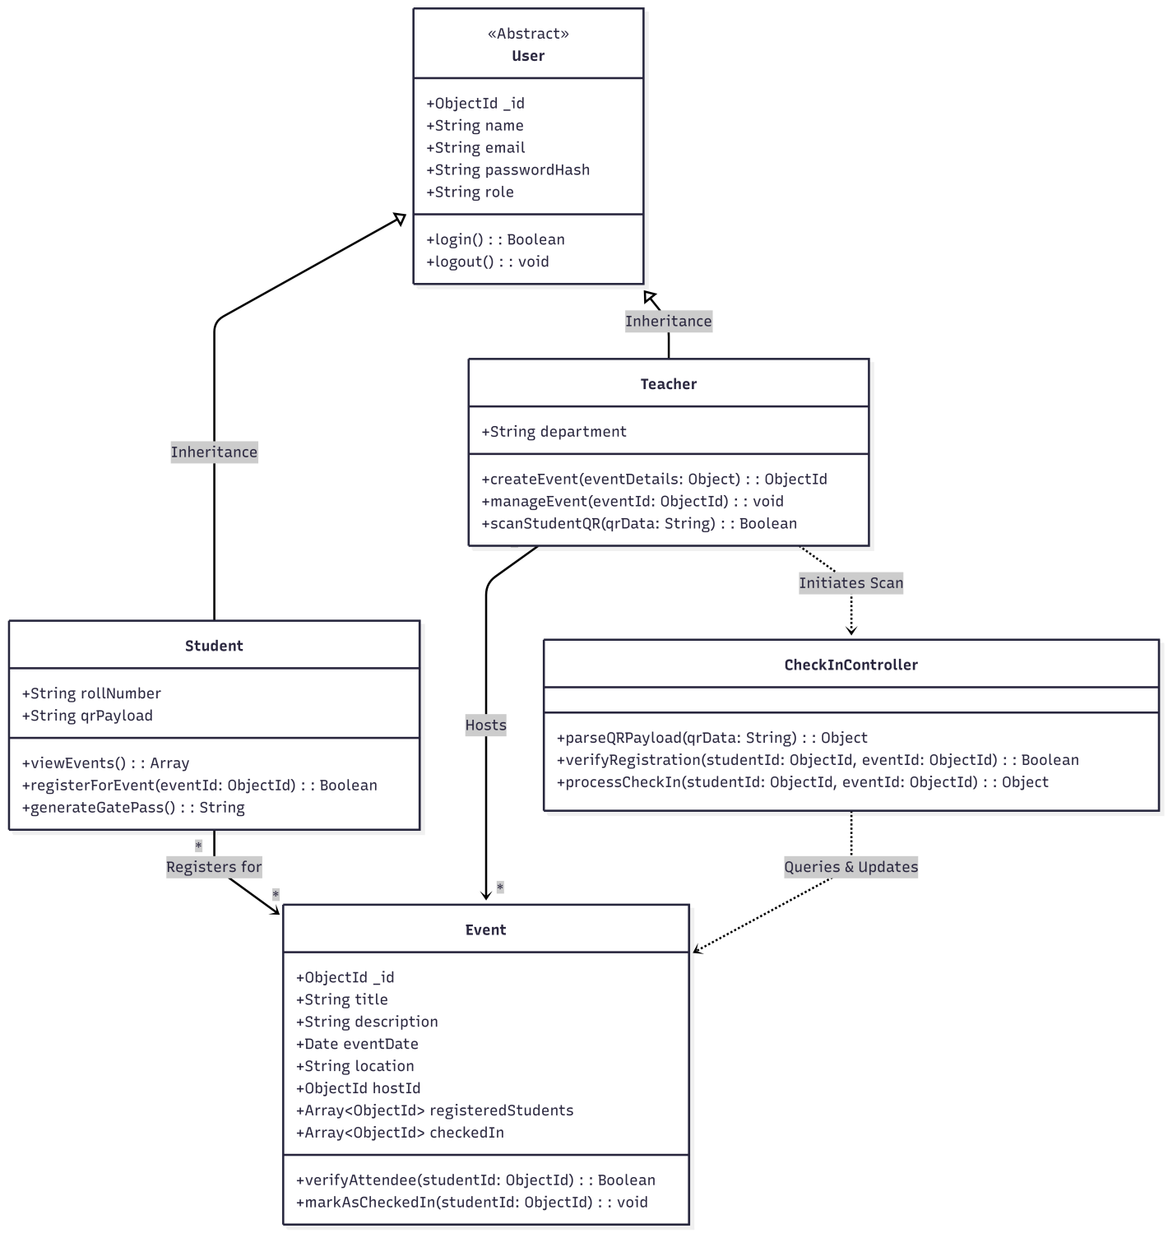

Figure 2.4 Class Diagram

2.3.5 Data Flow Diagram:
A data flow diagram (DFD) maps out the flow of information for any process or system. It uses defined symbols like rectangles, circles and arrows, plus short text labels, to show data inputs, outputs, storage points and the routes between each destination. A Data Flow Diagram (DFD) is traditional visual representation of the information flows within a system. A neat and clear DFD can depict a good amount of the system requirements graphically. It can be manual, automated, or combination of both.

It shows how information enters and leaves the system, what changes the information and where information is stored. The purpose of a DFD is to show the scope and boundaries of a system as a whole. It may be used as a communications tool between a systems analyst and any person who plays a part in the system that acts as the starting point for redesigning a system. [3]

It is usually beginning with a context diagram as the level 0 of DFD diagram, a simple representation of the whole system. To elaborate further from that, we drill down to a level 1 diagram with lower level functions decomposed from the major functions of the system. This could continue to evolve to become a level 2 diagram when further analysis is required. Progression to level 3, 4 and so on is possible but anything beyond level 3 is not very common. Please bear in mind that the level of details for decomposing particular function really depending on the complexity that function. For further reading use the link given below:
https://www.visual-paradigm.com/guide/data-flow-diagram/what-is-data-flow-diagram/

DFD Diagram Notations

External Entity
An external entity can represent a human, system or subsystem. It is where certain data comes from or goes to. It is external to the system we study, in terms of the business process. For this reason, people used to draw external entities on the edge of a diagram.
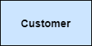

Process
A process is a business activity or function where the manipulation and transformation of data takes place. A process can be decomposed to finer level of details, for representing how data is being processed within the process.
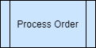

Data Store
A data store represents the storage of persistent data required and/or produced by the process. Here are some examples of data stores: membership forms, database table, etc.
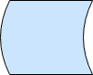

Data Flow
A data flow represents the flow of information, with its direction represented by an arrow head that shows at the end(s) of flow connector.
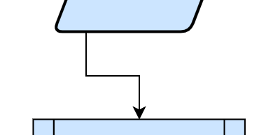
Context Diagram:

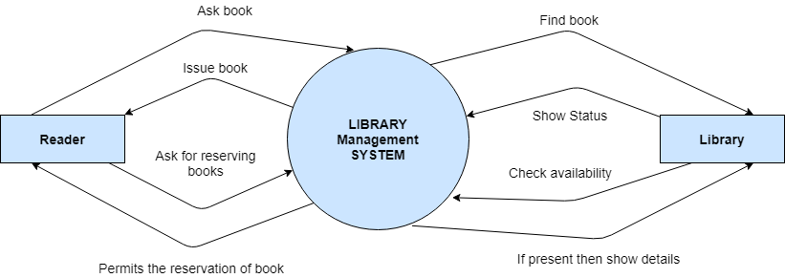
Figure 2.5 Context Diagram

Level 0:

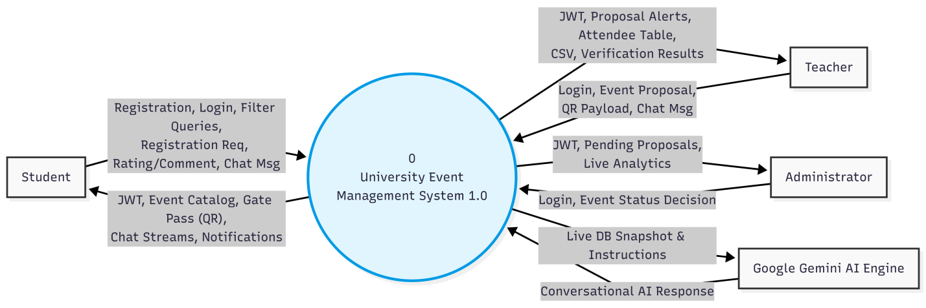
Figure 2.6 Level 0 DFD

Level 1:

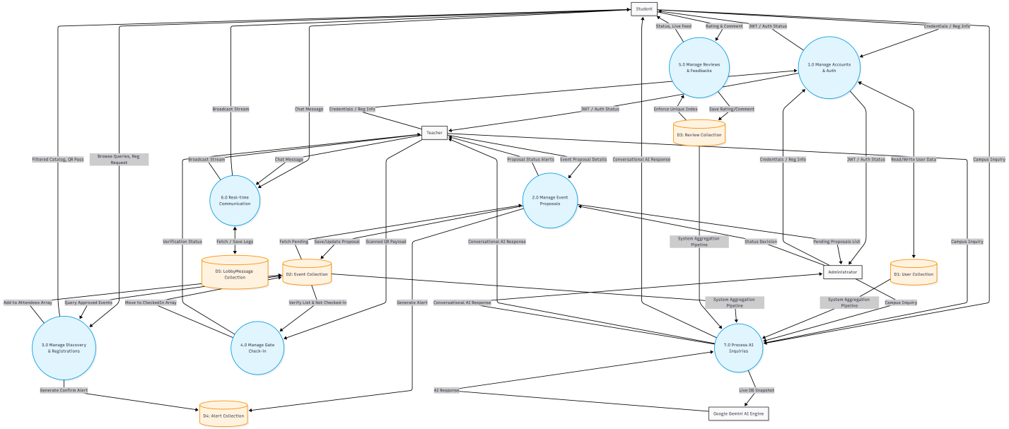

Figure 2.7 Level 1 DFD

The Data Dictionary provides a comprehensive definition of the database structure, data types, constraints, validations, and relationships for each collection within the University Event Management System (UEMS) MongoDB database. Below are the details for each database entity:

Table 2. 2: User Collection Schema
Field Name | Data Type | Required | Constraints & Validations | Description
_id | ObjectId | Yes | Auto-generated primary key | Unique identifier of the user record.
username | String | Yes | Unique, Lowercase, Trimmed, Indexed | Unique screen handle chosen by user.
email | String | Yes | Unique, Lowercase, Trimmed | Registered institutional email address.
fullName | String | Yes | Trimmed, Indexed | User's complete official name.
avatar | String | Yes | Valid URL | Cloudinary secure link to profile image.
password | String | Yes | Bcrypt hashed (10 rounds) | Secure hashed password credential.
refreshToken | String | No | None | Persistent token for keeping sessions active.
role | String | Yes | Enum: ['student', 'teacher', 'admin'], default: 'student' | Controls permissions and routing access.
major | String | No | Default: 'Classical Studies' | Academic program department for student profile.
createdAt | Date | Yes | Auto-populated by Mongoose | Creation timestamp of user account.
updatedAt | Date | Yes | Auto-populated by Mongoose | Modification timestamp of user account.

Table 2. 3: Event Collection Schema
Field Name | Data Type | Required | Constraints & Validations | Description
_id | ObjectId | Yes | Auto-generated primary key | Unique identifier of the event record.
title | String | Yes | Max length 150 | The title/name of the campus event.
description | String | Yes | Narrative text | Complete description of event details.
date | Date | Yes | Valid date format | Scheduled date of the event.
time | String | Yes | None | Scheduled time of the event.
location | String | Yes | None | Physical venue/campus location.
coverImage | String | No | Valid URL | Cloudinary URL for event cover banner.
category | String | Yes | Default: 'GENERAL' | Category type (Academic, Tech, Sports, etc.).
department | String | Yes | Default: 'All Departments' | Target student department.
status | String | Yes | Enum: ['pending', 'approved', 'rejected'], default: 'pending' | State of administrative approval workflow.
organizer | ObjectId | Yes | Reference -> User collection | The teacher hosting the event.
attendees | Array(ObjectId) | No | Reference -> User collection | List of registered student IDs.
checkedIn | Array(ObjectId) | No | Reference -> User collection | List of checked-in student IDs verified at entrance.
createdAt | Date | Yes | Auto-populated | Timestamp of event registration proposal.
updatedAt | Date | Yes | Auto-populated | Timestamp of last status modification.

Table 2. 4: Review Collection Schema
Field Name | Data Type | Required | Constraints & Validations | Description
_id | ObjectId | Yes | Auto-generated primary key | Unique identifier of the review record.
event | ObjectId | Yes | Reference -> Event collection | The reviewed event.
user | ObjectId | Yes | Reference -> User collection | The student submitting the review.
rating | Number | Yes | Min: 1, Max: 5 | Star rating out of 5 stars.
comment | String | Yes | Trimmed | Textual feedback commentary.
createdAt | Date | Yes | Auto-populated | Timestamp of review submission.

Table 2. 5: Alert Collection Schema
Field Name | Data Type | Required | Constraints & Validations | Description
_id | ObjectId | Yes | Auto-generated primary key | Unique identifier of the notification record.
user | ObjectId | Yes | Reference -> User collection | Target recipient of the alert notification.
title | String | Yes | Headline text | Brief title of notification alert.
message | String | Yes | Full text description | Detailed alert notification body.
type | String | Yes | Enum: ['info', 'warning', 'success', 'error'], default: 'info' | Status code for layout/styling in frontend.
isRead | Boolean | Yes | Default: false | Read/unread state indicator.
event | ObjectId | No | Reference -> Event collection | Associated event context if applicable.
category | String | Yes | Enum: ['general', 'registration', 'update', 'reminder'], default: 'general' | Purpose category of alert.
createdAt | Date | Yes | Auto-populated | Timestamp of notification dispatch.

Table 2. 6: LobbyMessage Collection Schema
Field Name | Data Type | Required | Constraints & Validations | Description
_id | ObjectId | Yes | Auto-generated primary key | Unique identifier of the message record.
event | ObjectId | Yes | Reference -> Event collection | Target event lobby room index.
user | ObjectId | Yes | Reference -> User collection | The user sending the message.
senderName | String | Yes | None | Sender display name for fast live rendering.
content | String | Yes | None | Text payload of the chat message.
createdAt | Date | Yes | Auto-populated | Message dispatch timestamp.

2.3.6 ER Diagram:

An entity relationship model, also called an entity-relationship (ER) diagram, is a graphical representation of entities and their relationships to each other, typically used in computing in regard to the organization of data within databases or information systems. An entity is a piece of data-an object or concept about which data is stored. To learn more about ERD visit: https://www.smartdraw.com/entity-relationship-diagram/
Below is example of ERD between customer and invoices in any xyz E-Billing system.

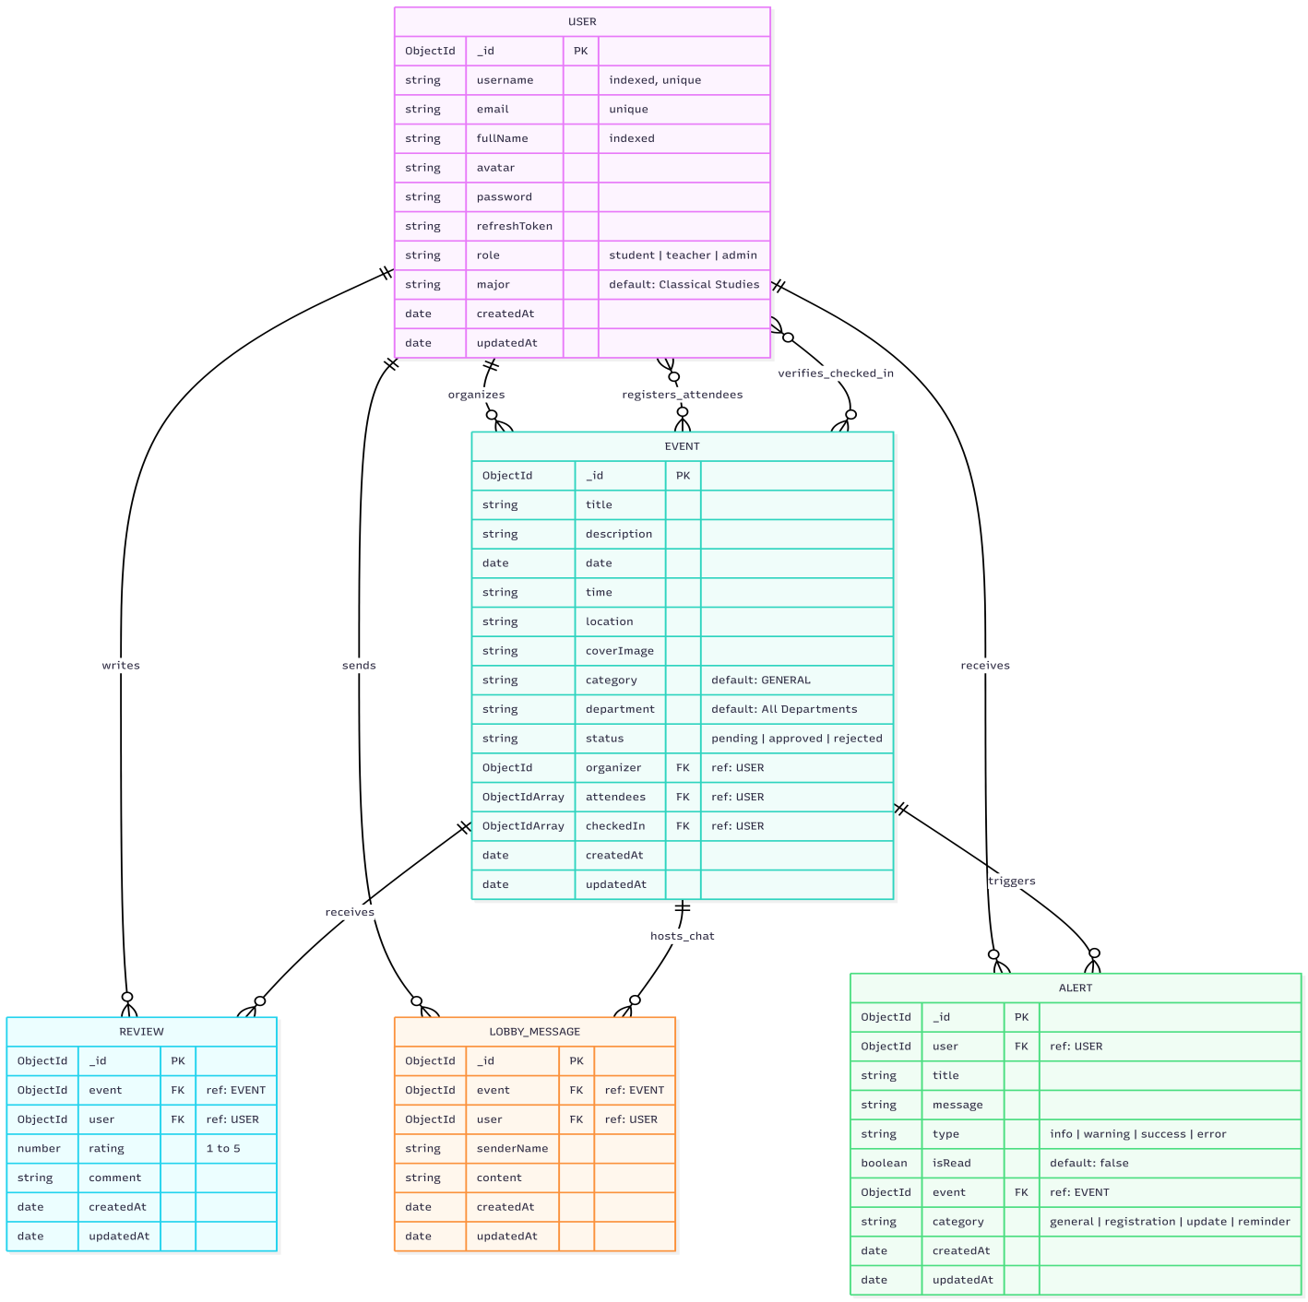

Figure 2.8 Entity Relationship Diagram

2.3.7 Database Model:
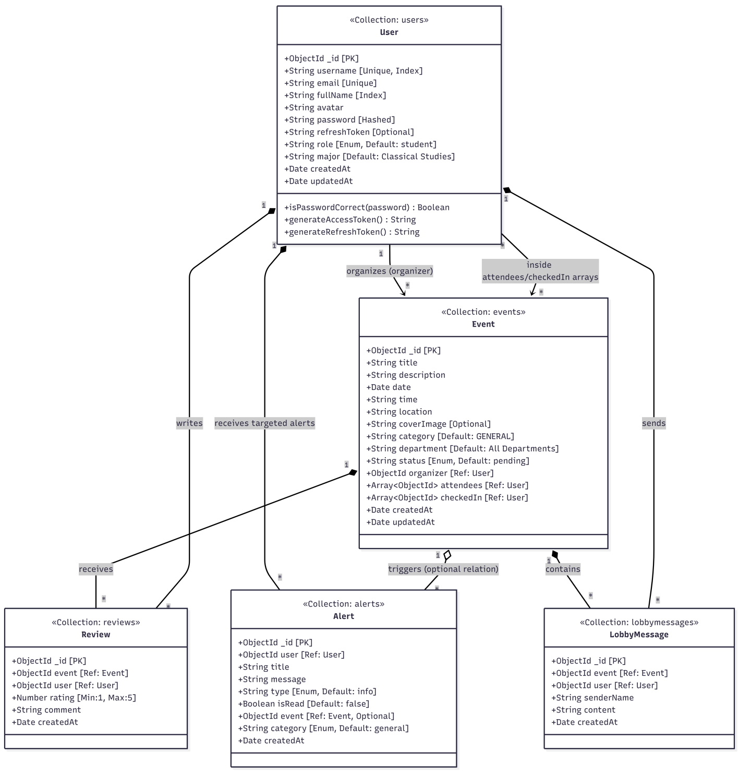

Figure 2.9 Database Model

2.3.8 Architecture:
3-Tier: (or N- Tier/multitier, chose whatever best suits your project nature)
The University Event Management System (UEMS) is designed using a modern 3-Tier Software Architecture (Client-Server-Database model). This architecture decouples the User Interface, Business Logic, and Data Persistence layers, providing high scalability, modularity, and security for the application.
Presentation Tier- This is the client-facing tier responsible for rendering the User Interface (UI), managing view states, and handling user interactions. The core framework powering this layer is React.js, which is built and bundled utilizing Vite to ensure optimized asset delivery and hot-module reloading. State management is handled through React's Context API, which is utilized to manage global states such as maintaining the AuthContext to seamlessly track logged-in user details, credentials, and real-time dashboard notifications. For routing, the system relies on React Router DOM on the client side, enforcing strict role-based route protection to ensure that only logged-in Teachers can access the event creation dashboard and only Admins can view the approval queue. Application programming interface (API) communication is facilitated by Axios, which acts as the primary HTTP client to perform asynchronous REST API requests to the backend while utilizing interceptors to securely pass HTTP-only cookies and access tokens. Furthermore, the frontend implements the socket.io-client library to maintain an active WebSocket connection, enabling instantaneous event notifications and live chat lobby participation.
Application Tier- This tier implements the core business rules, coordinates application workflows, processes incoming API requests, and handles integration with external services. It operates on a Node.js runtime environment powered by the Express.js web framework. API requests are mapped to specialized routers and subsequently handled by dedicated controller modules that isolate specific business logic, such as executing event approval state transitions or calculating available seats. The backend relies on several security and utility middlewares, including an authentication middleware that intercepts requests to extract and verify JSON Web Token (JWT) cryptographic signatures. This ensures user roles are validated before granting access to protected endpoints. Additionally, the server uses Multer to parse multi-part form data for incoming image uploads, while a global error handler centrally catches API exceptions to standardize JSON response schemas. Real-time features are driven by a WebSocket engine built on top of the Node.js HTTP server using Socket.io. This establishes persistent bidirectional channels, organizing users into specific event lobby rooms to execute instant broadcasts of chat messages. Finally, the server integrates the official Google Gen AI SDK to process natural language inquiries. The backend compiles a live data aggregate from the database, feeds it into the Gemini model context, and serves intelligent, context-aware campus responses back to users.
Data Tier- This tier is responsible for physical data storage, query execution, and transactional consistency. The primary database is MongoDB, a document-oriented NoSQL database that stores data in flexible, JSON-like formats to facilitate horizontal scaling. The system uses Mongoose as the Object Data Modeling (ODM) library to enforce strict schema definitions and perform data validation, such as enforcing specific rating boundaries. Mongoose also runs pre-save hooks for tasks like automatic Bcrypt password hashing and maps document references between various collections. To optimize database performance, specific fields such as the user's name and username are indexed to accelerate search queries. Furthermore, a Compound Unique Index is applied to the Review collection, linking the event and user to enforce business rules and completely prevent duplicate student reviews for any single event. For cloud asset storage, the architecture utilizes the Cloudinary Content Delivery Network (CDN) to offload heavy binary files. User avatars and event cover banners are uploaded directly to Cloudinary's high-speed media server, allowing the MongoDB database to store only the secure, lightweight URL strings pointing to these media assets.

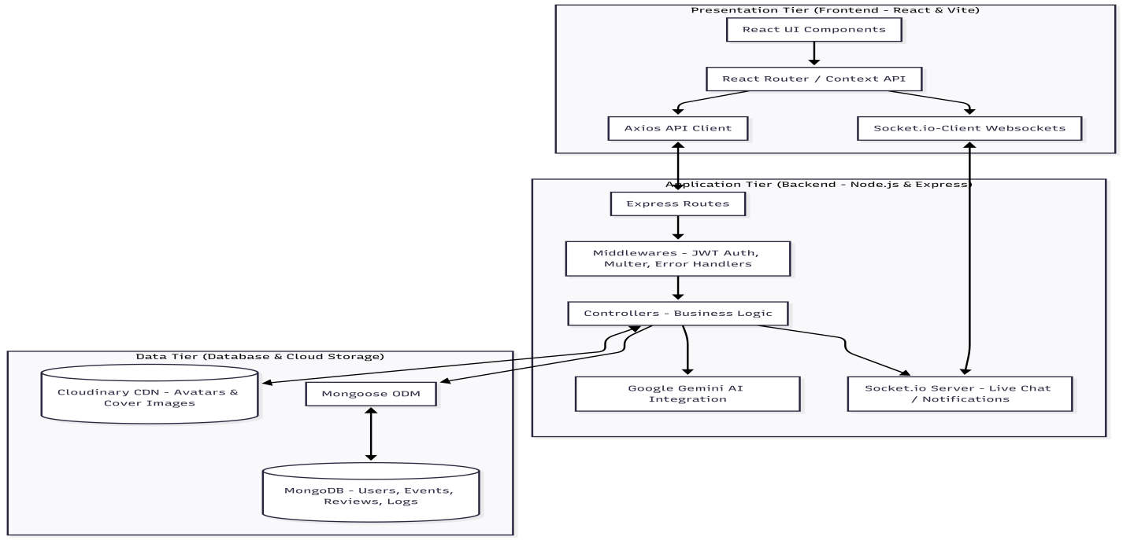

Figure 2.10 Application Architecture

Chapter 3 - RESULTS & DISCUSSION
In this chapter discuss overall performance or all functional and non-functional requirements you listed in chapter no. 1 as this section will verify the performance measures proposed for this project. For this software testing plays a vital role.

3.1 Testing:
Software testing is a critical phase in the software development lifecycle, utilized to evaluate the functionality of the University Event Management System (UEMS) and ensure it meets all specified functional and non-functional requirements. For this platform, testing was conducted across all three tiers of the architecture. The presentation tier (React UI) was tested for mobile responsiveness and state management. The application tier (Node.js/Express) underwent rigorous API endpoint testing using Postman to verify JWT authentication, secure routing, and database transactions. Furthermore, specialized integration testing was performed to validate the low-latency message broadcasting of the Socket.io WebSocket engine and the context-aware accuracy of the Google Gemini AI chatbot.

3.2 Test Cases:
Test cases need to be simple and transparent
Create test cases that are as simple as possible. They must be clear and concise as the author of the test case may not execute them.
Use assertive language like go to the home page, enter data, click on this and so on. This makes the understanding the test steps easy and tests execution faster.
Create Test Case with End User in Mind
The ultimate goal of any software project is to create test cases that meet customer requirements and is easy to use and operate. A tester must create test cases keeping in mind the end user perspective
Avoid test case repetition.
Do not repeat test cases. If a test case is needed for executing some other test case, call the test case by its test case id in the pre-condition column
Do not Assume
Do not assume functionality and features of your software application while preparing test case. Stick to the User Requirement Specification Documents.
Ensure 100% Coverage
Make sure you write test cases to check all software requirements mentioned in the specification document.
Test Cases must be identifiable.
Name the test case id such that they are identified easily while tracking defects or identifying a software requirement at a later stage. [2]

Test Case: User Login:
Below is test case format:

Table 3. 1: User login Test Case
Test Case ID: | TC-01
Test Case Title: | Verify User Registration functionality
Test Case Priority: | High
Requirement: | User Registration (FR-01)
Test Description: | Verify that a guest can successfully register on the platform with valid credentials and a profile avatar.
Test Date: | 05/18/2026
Pre-Conditions: | 1. Run the application.  2. Navigate to registration page.  3. Verify database server is active.
Dependencies: | Internet connection (for Cloudinary avatar storage upload).
Test Steps: | 1. Enter a valid unique username ('johndoe'), unique email ('johndoe@uaf.edu'), full name, and secure password.  2. Upload a valid avatar image ('avatar.png').  3. Click the 'Register' button.
Test Data | Username: 'johndoe', Email: 'johndoe@uaf.edu', Password: 'Password123!', Avatar: 'avatar.png'
Expected Results: | The system hashes the password, saves the user to MongoDB, uploads the avatar to Cloudinary, returns a success response, issues secure JWT tokens, and redirects the user to the student dashboard.
Actual Results: | As expected
Post Conditions: | A new user document is created in the database and the user session is authenticated.
Status: (Pass/Fail) | Pass
Other Comments: | None
Test Case ID: | TC-02
Test Case Title: | Verify User Login functionality
Test Case Priority: | High
Requirement: | User Login (FR-01)
Test Description: | Verify that a registered user can successfully log in using their credentials.
Test Date: | 05/18/2026
Pre-Conditions: | 1. An active user account exists in the database.  2. Open the login page.
Dependencies: | Database server.
Test Steps: | 1. Enter the registered email/username.  2. Enter the correct password.  3. Click the 'Sign In' button.
Test Data | Email: 'johndoe@uaf.edu', Password: 'Password123!'
Expected Results: | The system compares the hashed password, issues secure HTTP-only access and refresh tokens, and navigates the user to their role-specific dashboard.
Actual Results: | As expected
Post Conditions: | User session is authenticated and active.
Status: (Pass/Fail) | Pass
Other Comments: | None
Test Case ID: | TC-03
Test Case Title: | Verify User Logout functionality
Test Case Priority: | High
Requirement: | User Logout (FR-01)
Test Description: | Verify that a logged-in user can log out of the platform securely.
Test Date: | 05/18/2026
Pre-Conditions: | 1. User is authenticated.  2. User is on the dashboard.
Dependencies: | Auth cookie storage.
Test Steps: | 1. Click the 'Logout' button on the navigation bar.
Test Data | Active JWT session cookies.
Expected Results: | The system clears the access and refresh token cookies from the browser, deletes the refresh token from the database, and redirects the user to the login page.
Actual Results: | As expected
Post Conditions: | User session is invalidated, and protected routes become inaccessible.
Status: (Pass/Fail) | Pass
Other Comments: | None
Test Case ID: | TC-04
Test Case Title: | Verify Event Discovery and Filtering functionality
Test Case Priority: | Medium
Requirement: | Browse Events (FR-02)
Test Description: | Verify that a student can browse and filter approved campus events by category and department.
Test Date: | 05/18/2026
Pre-Conditions: | 1. Approved events exist in the database.  2. User is logged in as a student.
Dependencies: | Event collection database availability.
Test Steps: | 1. Navigate to the 'Events' discovery page.  2. Apply a category filter (e.g. 'TECHNICAL').  3. Apply a department filter (e.g. 'Computer Science').
Test Data | Filter options selected: Category='TECHNICAL', Department='Computer Science'
Expected Results: | The system runs queries in real time and returns a list of events matching only the selected category and department filters.
Actual Results: | As expected
Post Conditions: | Filtered events are dynamically rendered in the catalog.
Status: (Pass/Fail) | Pass
Other Comments: | None
Test Case ID: | TC-05
Test Case Title: | Verify Event Registration functionality
Test Case Priority: | High
Requirement: | Register for Event (FR-02)
Test Description: | Verify that a student can register for an upcoming approved event.
Test Date: | 05/18/2026
Pre-Conditions: | 1. Student is logged in.  2. Event has available capacity and status is 'approved'.
Dependencies: | Registration rules.
Test Steps: | 1. Open the target event details page.  2. Click the 'Register' button.
Test Data | Student ID: 'johndoe_id', Event ID: 'event_tech_id'
Expected Results: | The system registers the student in the event's attendee list, generates a secure digital gate pass containing a QR code, and triggers a success notification.
Actual Results: | As expected
Post Conditions: | Student ID is added to the event's 'attendees' database array.
Status: (Pass/Fail) | Pass
Other Comments: | None
Test Case ID: | TC-06
Test Case Title: | Verify Post-Event Review Submission functionality
Test Case Priority: | Medium
Requirement: | Submit Event Review (FR-02)
Test Description: | Verify that a student can submit a rating and comment for a past event they registered for, and cannot submit multiple reviews.
Test Date: | 05/18/2026
Pre-Conditions: | 1. Event has concluded.  2. Student registered for and attended the event.
Dependencies: | Database review collection indexing.
Test Steps: | 1. Navigate to the past event page.  2. Select a rating (e.g. 5 stars) and write a comment.  3. Click the 'Submit Review' button.  4. Attempt to submit a second review for the same event.
Test Data | Rating: 5, Comment: 'Great event! Highly organized.', Event ID: 'event_past_id'
Expected Results: | The first review is successfully saved. The second attempt is blocked with an error message due to the compound unique index constraint on the database.
Actual Results: | As expected
Post Conditions: | Review document is saved in the 'reviews' collection.
Status: (Pass/Fail) | Pass
Other Comments: | None
Test Case ID: | TC-07
Test Case Title: | Verify Event Proposal Submission functionality
Test Case Priority: | High
Requirement: | Submit Event Proposal (FR-03)
Test Description: | Verify that a teacher can submit a new event proposal.
Test Date: | 05/18/2026
Pre-Conditions: | 1. User is logged in as a Teacher.  2. Open the event creation form.
Dependencies: | Event schema and server connection.
Test Steps: | 1. Navigate to the 'Create Event' page.  2. Fill in the title, description, date, location, category.  3. Upload a cover banner image.  4. Click 'Submit Event'.
Test Data | Title: 'Tech Symposium 2026', Date: '06/20/2026', Category: 'TECHNICAL', Banner: 'banner.jpg'
Expected Results: | The system saves the event with status 'pending', uploads the banner to Cloudinary, and dispatches a dashboard alert to administrators.
Actual Results: | As expected
Post Conditions: | A pending event document is created in MongoDB.
Status: (Pass/Fail) | Pass
Other Comments: | None
Test Case ID: | TC-08
Test Case Title: | Verify Registered Attendee Table Export functionality
Test Case Priority: | Low
Requirement: | Export Attendee List (FR-03)
Test Description: | Verify that a teacher can view and export the registered student attendee table as a CSV file.
Test Date: | 05/18/2026
Pre-Conditions: | 1. Teacher is logged in.  2. Students have registered for the teacher's event.
Dependencies: | Browser file system download privileges.
Test Steps: | 1. Open the teacher's event dashboard.  2. View the real-time registered student table.  3. Click the 'Export to CSV' button.
Test Data | Target Event ID: 'event_tech_id'
Expected Results: | The system compiles all registered student data for that event and downloads a structured '.csv' file.
Actual Results: | As expected
Post Conditions: | CSV file is generated and downloaded by the client browser.
Status: (Pass/Fail) | Pass
Other Comments: | None
Test Case ID: | TC-09
Test Case Title: | Verify QR Gate Pass Check-in functionality
Test Case Priority: | High
Requirement: | Scan QR Code Check-in (FR-04)
Test Description: | Verify that the gate checker/host can scan a student's QR pass and verify their check-in.
Test Date: | 05/18/2026
Pre-Conditions: | 1. Teacher is logged in and at the gate check-in page.  2. Student possesses a valid QR gate pass.
Dependencies: | QR Scanner library integration.
Test Steps: | 1. Scan the student's digital QR gate pass at the entrance.  2. Verify the parsed payload matches an active registration.  3. Attempt to scan the same QR pass a second time.
Test Data | Scanned QR payload: '{"studentId":"johndoe_id","eventId":"event_tech_id"}'
Expected Results: | The first scan marks the student as checked in and updates the dashboard. The second scan throws an error 'User already checked in'.
Actual Results: | As expected
Post Conditions: | Student ID is added to the event's 'checkedIn' database array.
Status: (Pass/Fail) | Pass
Other Comments: | None
Test Case ID: | TC-10
Test Case Title: | Verify Real-Time Chat Lobby functionality
Test Case Priority: | Medium
Requirement: | Participate in Chat Lobby (FR-05)
Test Description: | Verify that registered attendees can participate in a real-time event chat lobby.
Test Date: | 05/18/2026
Pre-Conditions: | 1. Users are logged in.  2. Users are registered for the target event.
Dependencies: | Active Socket.io server connection.
Test Steps: | 1. Join the event's live chat lobby.  2. Type a message and click send.
Test Data | Message: 'Looking forward to the event tomorrow!', Event ID: 'event_tech_id'
Expected Results: | The message is instantly broadcast to all active socket users in the lobby room without page refresh and saved persistently in MongoDB.
Actual Results: | As expected
Post Conditions: | A new chat log document is saved in the 'lobbymessages' collection.
Status: (Pass/Fail) | Pass
Other Comments: | None
Test Case ID: | TC-11
Test Case Title: | Verify Gemini AI Chatbot Inquiry functionality
Test Case Priority: | Medium
Requirement: | Query AI Chatbot (FR-06)
Test Description: | Verify that users can chat with the intelligent Gemini AI bot to get real-time event details.
Test Date: | 05/18/2026
Pre-Conditions: | 1. User is logged in.  2. Open the chatbot panel.
Dependencies: | Google Gemini API connection.
Test Steps: | 1. Open chatbot panel.  2. Type an inquiry: 'Are there any upcoming tech events next month?'
Test Data | Question string: 'Are there any upcoming tech events next month?'
Expected Results: | The system runs an aggregation pipeline to snapshot the database, feeds it to Gemini under strict sandboxing instructions, and prints a conversational, accurate, and secure AI response.
Actual Results: | As expected
Post Conditions: | Chat log is rendered in the UI.
Status: (Pass/Fail) | Pass
Other Comments: | None
Test Case ID: | TC-12
Test Case Title: | Verify Admin Event Proposal Approval/Rejection functionality
Test Case Priority: | High
Requirement: | Approve / Reject Event (FR-07)
Test Description: | Verify that an administrator can approve or reject a pending event proposal.
Test Date: | 05/18/2026
Pre-Conditions: | 1. Admin is logged in.  2. Pending event proposals exist in the database.
Dependencies: | Admin authorization privileges.
Test Steps: | 1. Navigate to the administrator approval console.  2. Select a pending event.  3. Click 'Approve'.
Test Data | Event ID: 'event_pending_id'
Expected Results: | The event status changes from 'pending' to 'approved' in MongoDB, the event is published to the catalog, and the teacher receives a real-time dashboard notification.
Actual Results: | As expected
Post Conditions: | Event status updated to 'approved' in MongoDB.
Status: (Pass/Fail) | Pass
Other Comments: | None
Test Case ID: | TC-13
Test Case Title: | Verify Administrative Analytics Dashboard functionality
Test Case Priority: | Low
Requirement: | View Admin Analytics (FR-07)
Test Description: | Verify that the administrator can view a compiled dashboard of platform analytics.
Test Date: | 05/18/2026
Pre-Conditions: | 1. Admin is logged in.  2. System contains historical data.
Dependencies: | Front-end chart library (e.g. Recharts).
Test Steps: | 1. Navigate to the main Admin Dashboard page.
Test Data | Database historical records.
Expected Results: | The system dynamically runs aggregation pipelines to compile platform metrics and renders charts representing monthly growth and category distributions.
Actual Results: | As expected
Post Conditions: | Platform metrics are visualised in the browser dashboard.
Status: (Pass/Fail) | Pass
Other Comments: | None

3.3 Conclusion:
The development and extensive testing of the University Event Management System (UEMS) demonstrate the successful deployment of a highly responsive, secure, and modern digital governance platform. The primary objective of transitioning the campus from manual, paper-based workflows to a centralized digital ecosystem has been thoroughly met. Throughout the testing phase, all core functional requirements—ranging from strict Role-Based Access Control (RBAC) to dynamic QR code generation—performed seamlessly under simulated operational loads.
From a UI/UX (User Interface and User Experience) perspective, the application provides an exceptionally modern and intuitive feel. Built using React and styled with Tailwind CSS, the presentation tier adheres strictly to mobile-first design principles. This is particularly critical for the student demographic, who primarily browse event catalogs and display their digital QR gate passes via mobile devices. The interfaces avoid technical clutter, utilizing descriptive helper tooltips, clean navigational sidebars, and highly legible data tables for teachers managing attendee lists. The UI is designed to be highly forgiving; comprehensive client-side form validation prevents user errors before they reach the server, while standardized error boundaries ensure that any backend failures fail gracefully without breaking the user's view.
Technically, the system's performance metrics are highly satisfactory. The decoupled MERN stack architecture proved to be highly scalable. The integration of Socket.io for the event chat lobbies yielded near-instantaneous bidirectional communication, successfully broadcasting messages to active clients well within the 500-millisecond non-functional requirement limit. Furthermore, the gate check-in process, which relies on parsing encrypted QR payloads and updating the MongoDB checkedIn array, executes in less than one second. This rapid transaction speed confirms that the system will successfully eliminate physical bottlenecks at event venue entrances.
The integration of the Google Gemini API also proved to be a significant value addition, successfully transforming standard database aggregates into conversational, intelligent campus assistance while maintaining strict data privacy through sandboxed system prompts. In conclusion, UEMS not only satisfies all proposed functional and non-functional requirements but also delivers a highly polished, user-friendly, and technologically advanced solution that significantly elevates the standard of event coordination and campus engagement at the university.

Chapter 4 - USER MANUAL

Figure 3.1 Signing in

